### Activity 1

Fill in the following parts of the Business Model diagram for Bright Spark (at the end of this document), using Figure 1.1 as a guide.

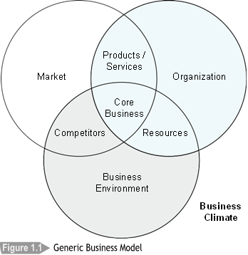

1. Replace Market with the name of the field in which Bright Spark’s customers are located.
2. Replace Business Environment with the name of the industry in which Bright Spark trades.

1. Replace "Market" with the name of the field in which Bright Spark’s customers are located.

- Field: Home & Commercial Lighting

2. Replace "Business Environment" with the name of the industry in which Bright Spark trades.

- Industry: Lighting Retail Industry

Prepare the following lists:

1. Products and services that Bright Spark offers to customers.

- Bulbs

- Lamps

- Lampshades

- Technical advice for customers

- Occasional electrical work for customers

2. Resources that Bright Spark needs to provide the products and services:

- Sources of Finance: Revenue from sales, potential business loans or investments

- Equipment: Store fixtures, lighting testing equipment, IT infrastructure for e-business

- Skills: Knowledge in light fittings, electrical expertise, customer service skills

- Assets: Physical stores, warehouses, online sales platform

- Information: Market trends, customer preferences, inventory data, sales data, competitor pricing and products

3. Competitors who provide the same or similar products to Bright Spark in your local market:

- IKEA

- B&Q

Complete the following parts of Bright Spark’s Business Model:

1. Products and Services

- Retail of light fittings: bulbs, lamps, lampshades

- Technical advice and support to customers

- Electrical services upon request

2. Core Business (i.e., what is its main purpose)

- To provide high-quality lighting solutions and unmatched customer service, emphasizing technical expertise and support. Bright Spark aims to cater to the diverse needs of customers across regions while expanding its brand reach.

3. Resources

- Physical: 63 stores across UK, two warehouses, online sales platform

- Human: Area managers, store managers, bookkeepers, other support staff

- Financial: Revenue from sales, potential external investments or loans

- Technological: IT infrastructure supporting e-business and other operational processes

- Knowledge & Skills: Expertise in light fittings, electrical knowledge, market understanding, and customer service skills

4. Competitors

- IKEA

- B&Q

- Other local lighting retailers in regions where Bright Spark operates

This Business Model snapshot gives a comprehensive view of Bright Spark's operations, allowing for strategic planning and informed decision-making.

